LAB – 2 REPORT
Topic: Parents Struggle to Track Children’s Learning Progress
CONTEXT:
Parents using school apps and online portals often struggle with:
- Unclear academic reports
- Too much scattered information
- Difficulty understanding performance trends
- Limited interaction with teachers
- Time constraints due to work or household duties
- Complex user interfaces
- Lack of summarized insights
This lab helps understand real challenges faced by parents and design empathetic digital solutions to improve parental involvement.
STEP 1:
Identify User Groups
Group – 1: Homemaker Parents
- Age: 30–45 years
- Education: SSLC / PUC
- Device: Smartphone
- Digital Literacy: Moderate
- Usage: Regularly checks school apps

Group – 2: Working Parents
- Age: 35–45 years
- Education: PUC / Degree
- Device: Smartphone
- Digital Literacy: Basic to Moderate
- Usage: Limited due to busy schedule

STEP 2: Initial Assumptions
Sample Assumptions:
- Parents find school apps confusing
- Reports are difficult to interpret
- Parents want simple summaries
- Time constraints affect involvement
- Too much data causes confusion
Assumption Table
ID | Assumption
A1 | Parents find academic reports confusing
A2 | Too much data causes information overload
A3 | Parents prefer simple summaries
A4 | Lack of clarity increases anxiety

STEP 3: Interview Questions:
- How do you track your child’s academic progress?
- Do you find school apps easy to use?
- Do you understand academic reports clearly?
- What challenges do you face while checking marks?
- How confident are you about your child’s performance?
- What would make tracking easier for you?

STEP 4: User Interview
Group – 1: Homemaker Parent
- Do you track progress regularly?
Yes, I check school apps often.
- Is it easy to understand reports?
No, they are confusing.
- Do you understand subject performance?
Not clearly.
- Are updates helpful?
There are too many updates.
- Confidence level about child’s progress?
Low, I feel unsure.
- What do you prefer?
Simple summary reports.
Group – 2: Working Parent
- Do you check school apps regularly?
Not often, due to busy schedule.
- Are reports easy to understand?
No, they are complex.
- Do you get clear progress insights?
No, I don’t know overall performance.
- Biggest problem?
Lack of time and clarity.
- Preferred solution?
Quick summaries and alerts.
- Offline vs digital updates?
Prefer simple digital summaries.

STEP 5:
Group -1
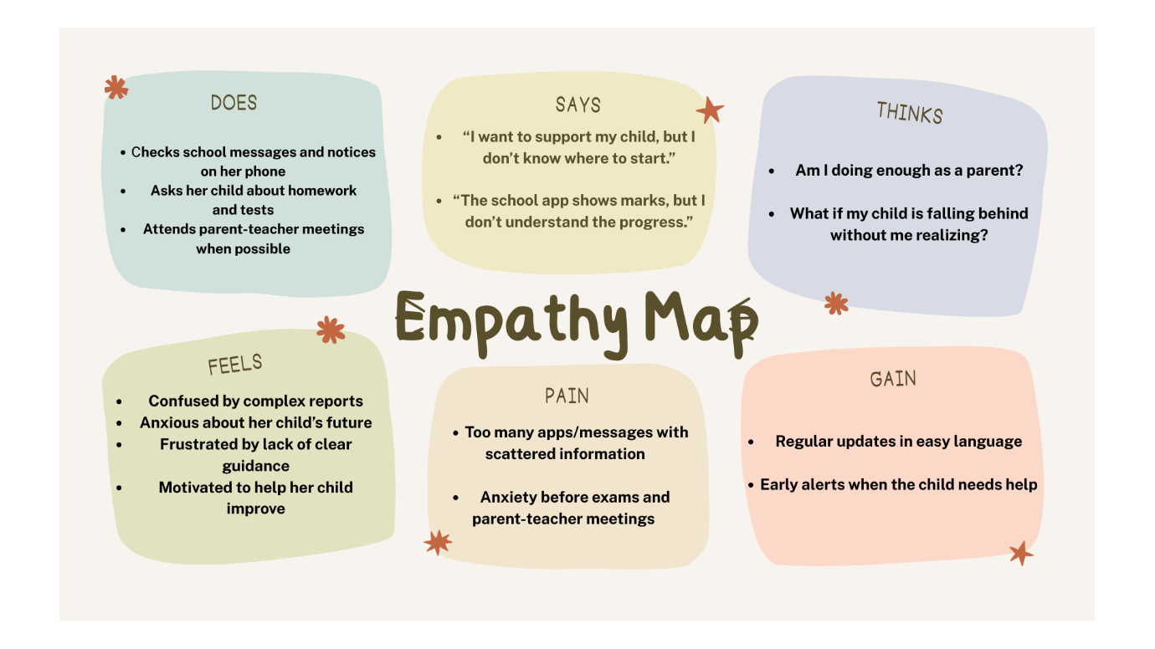
Group -2
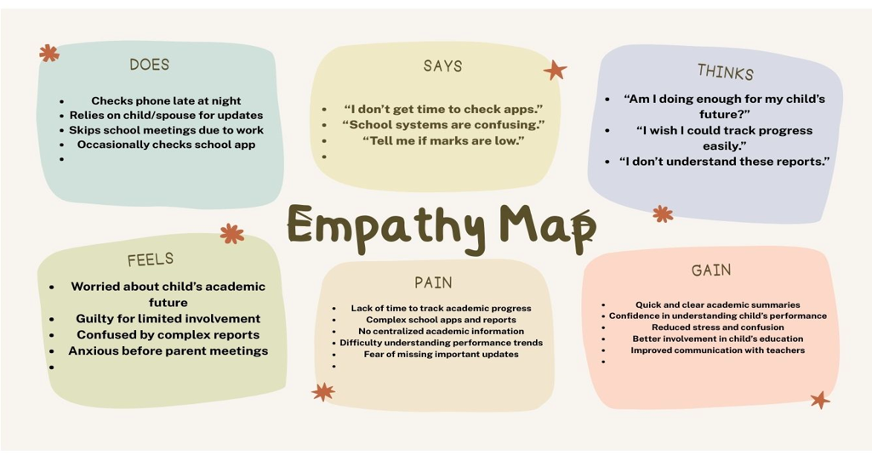

STEP 6: Validate Assumptions
Group – 1 Validation
Assumption | Validated | Reason
Reports confusing | YES | Users struggle to interpret data
Too much data | YES | Multiple updates cause confusion
Needs summary | YES | Parents prefer simple insights
Anxiety present | YES | Unclear progress creates stress

Group – 2 Validation
Assumption | Validated | Reason
Lack of time | YES | Working parents are busy
Reports confusing | YES | Hard to interpret quickly
Needs quick updates | YES | Prefers alerts
Low involvement | YES | Time constraint

STEP 7: User Insights
Group – 1 Insights
- Needs clarity over quantity of information
- Emotional stress due to confusion
- Prefers visual summaries
- Wants teacher feedback in simple language

Group – 2 Insights
- Needs time-efficient solutions
- Prefers alerts and highlights
- Wants quick performance overview
- Needs centralized information

STEP 8: User Persona
Group -1 Persona:
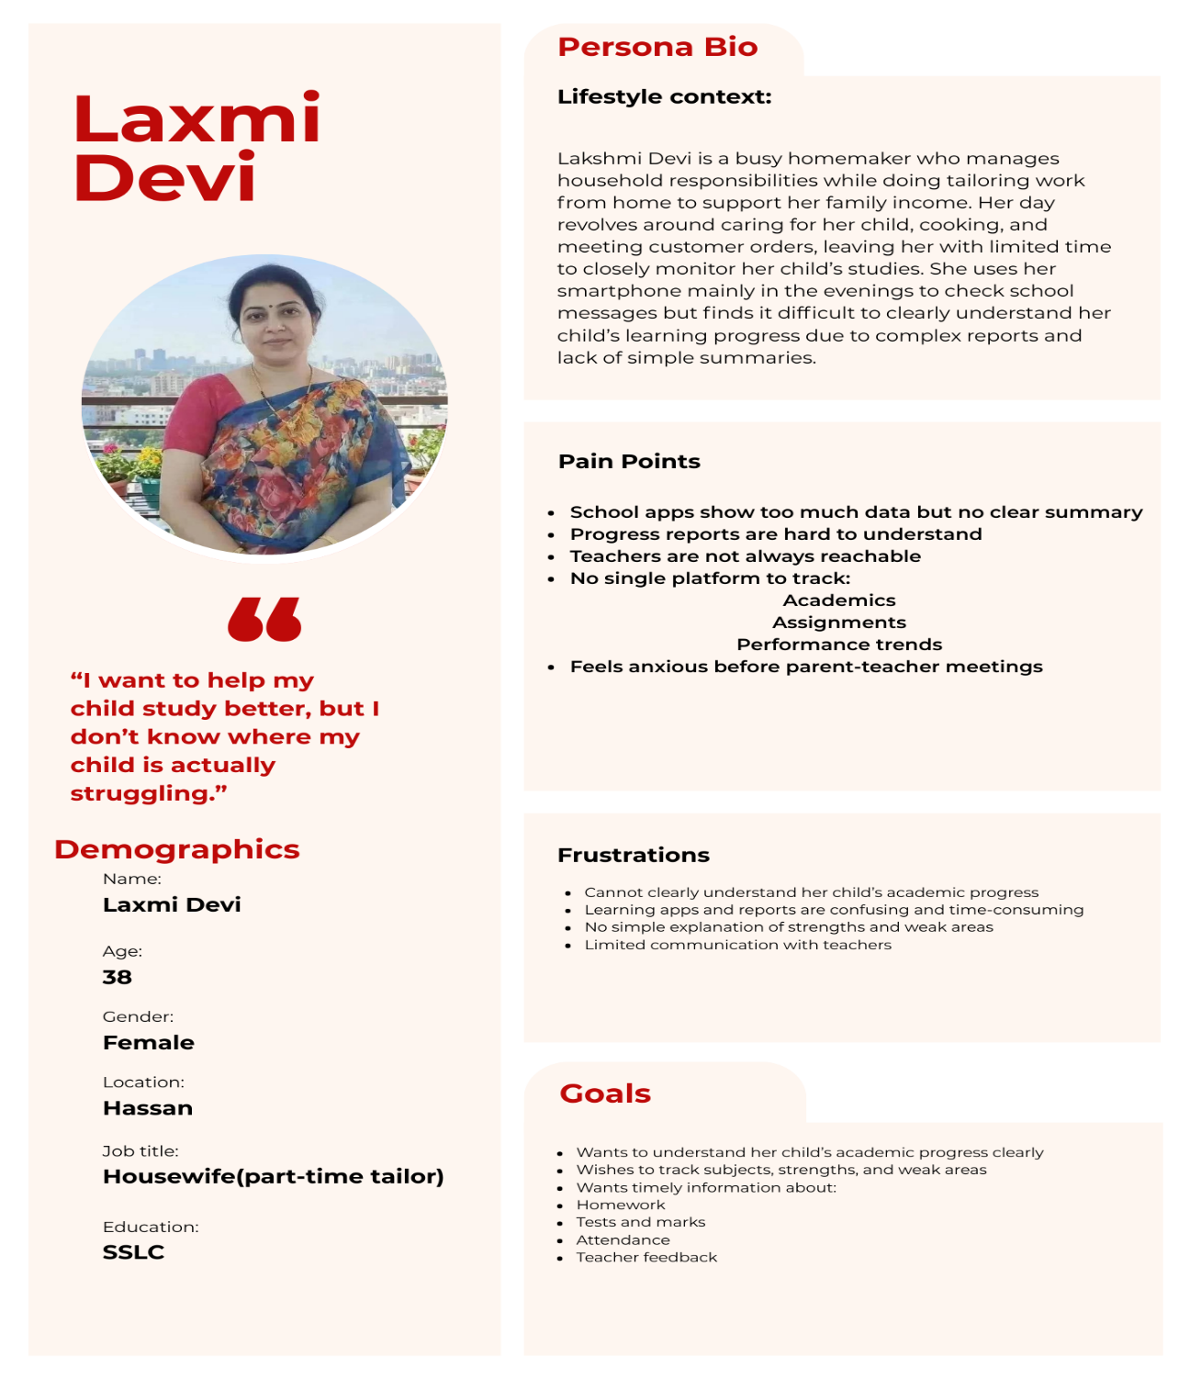
Group -2 Persona :

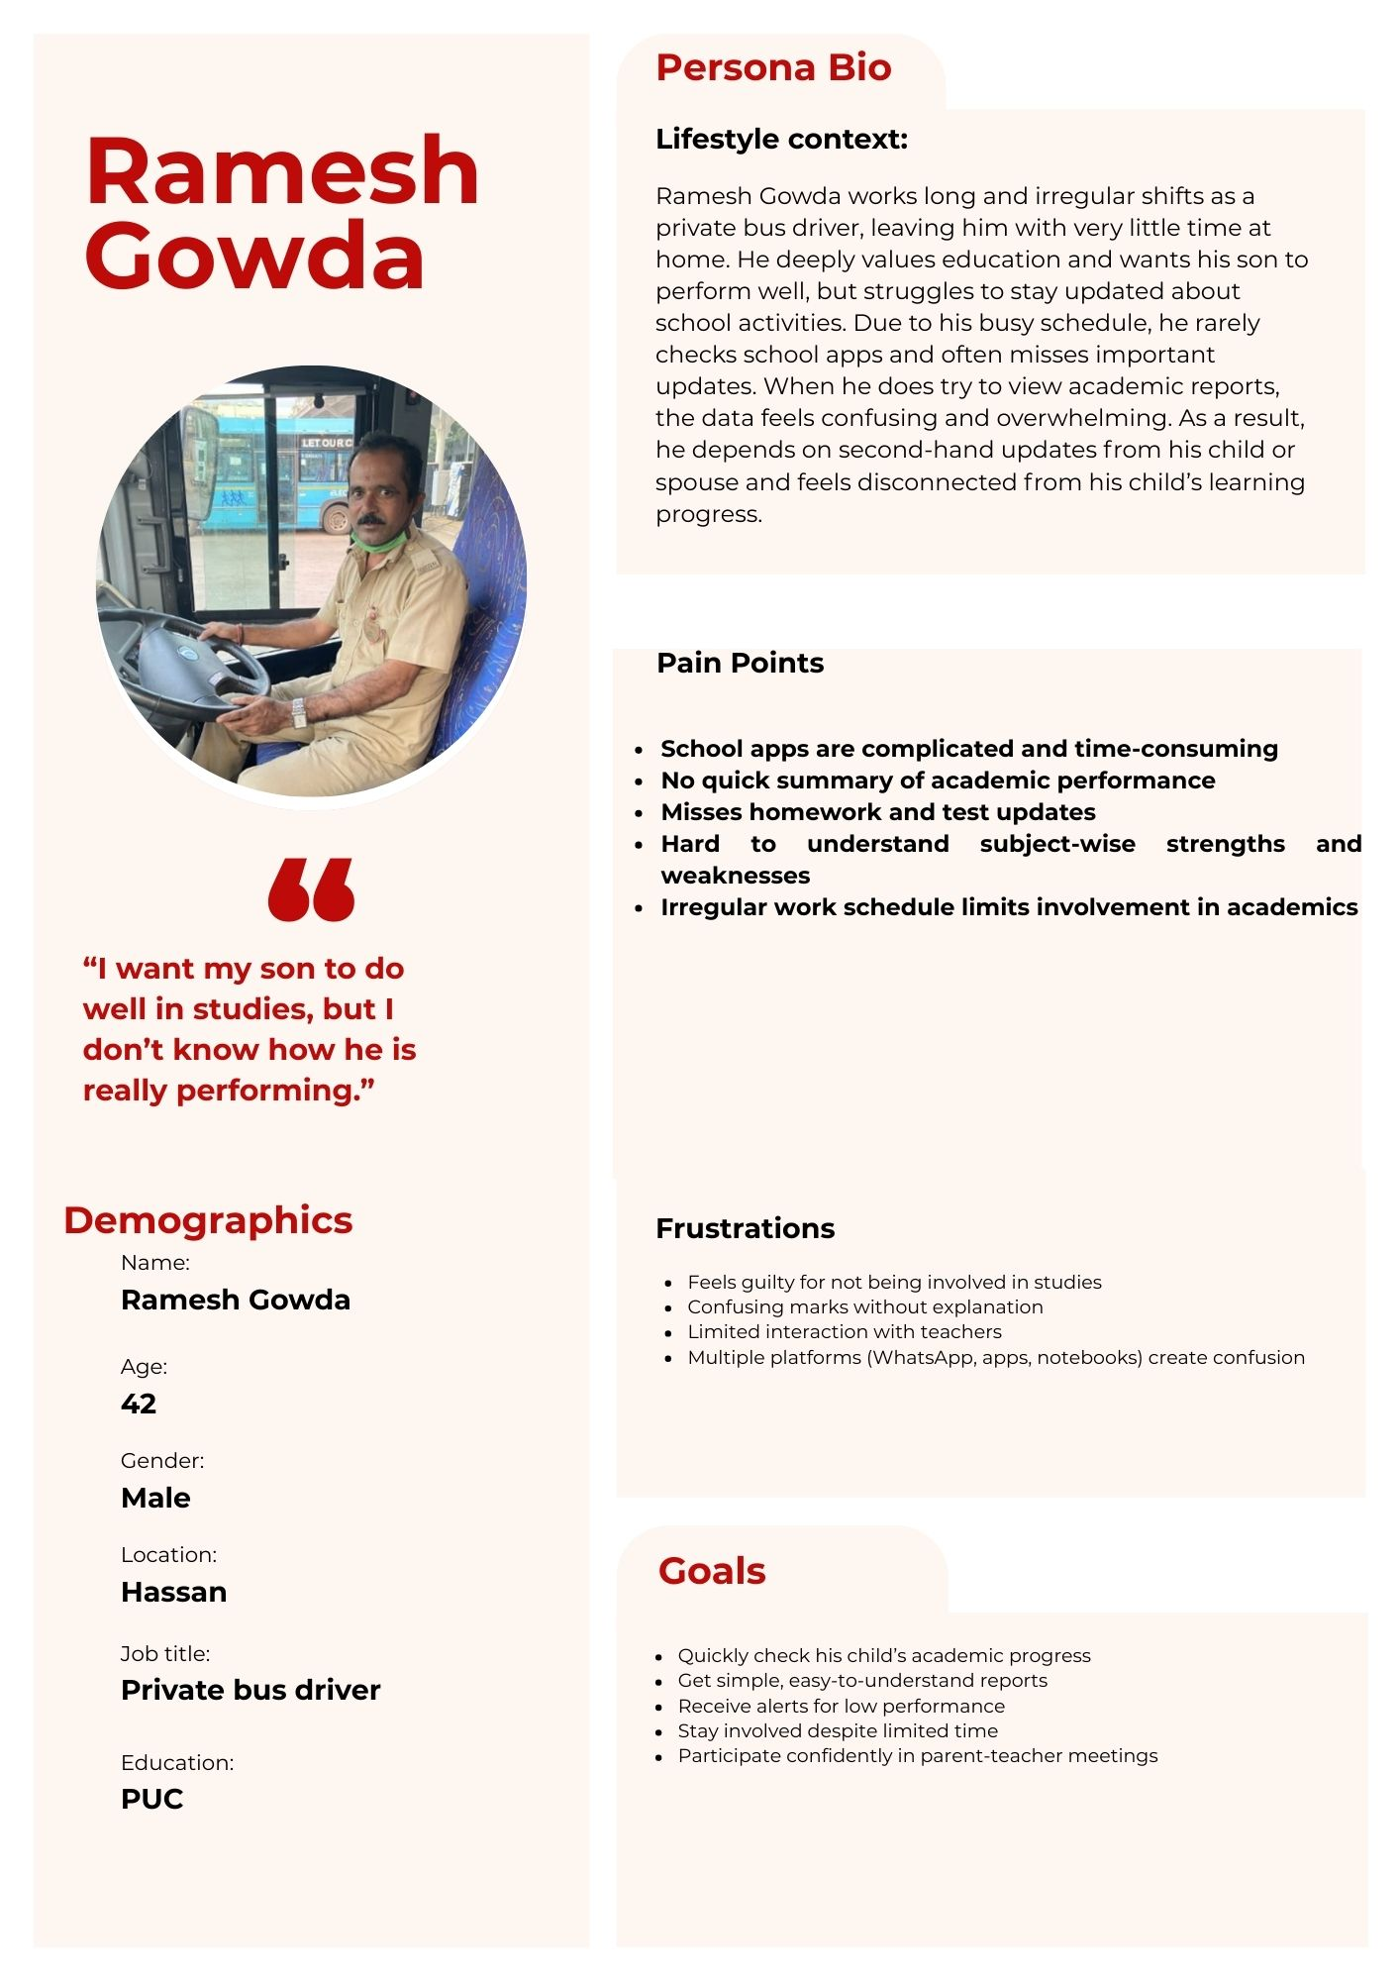

STEP 9: Translate Insights to Software Needs
Insight | Software Requirement
Confusing reports | Simple dashboard
Too much data | Summarized insights
Time constraints | Quick alerts
Emotional stress | Clear visual reports
Scattered platforms | Single unified app
Language barriers | Regional language suppor
STEP 10: Reflection & Documentation
Reflection:
- Parents struggle more with clarity than access to information.
- Emotional stress plays a major role.
- Both user groups want simple and clear insights.
- The real issue is usability, not availability of data.

Documentation:
User Groups: Homemaker & Working Parents
Problems Identified:
- Confusing academic reports
- Too much scattered information
- Limited time for tracking
- Anxiety due to unclear progress
- Poor usability of apps

User Needs
- Simple and intuitive interface
- Clear academic summaries
- Alerts for performance issues
- Centralized information platform
- Easy language and visualization

Name : Sonavi K
Register number : 24BEIS122

